## **UML DIAGRAMS**

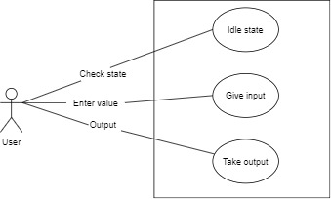

Fig 1: Use Case Diagram

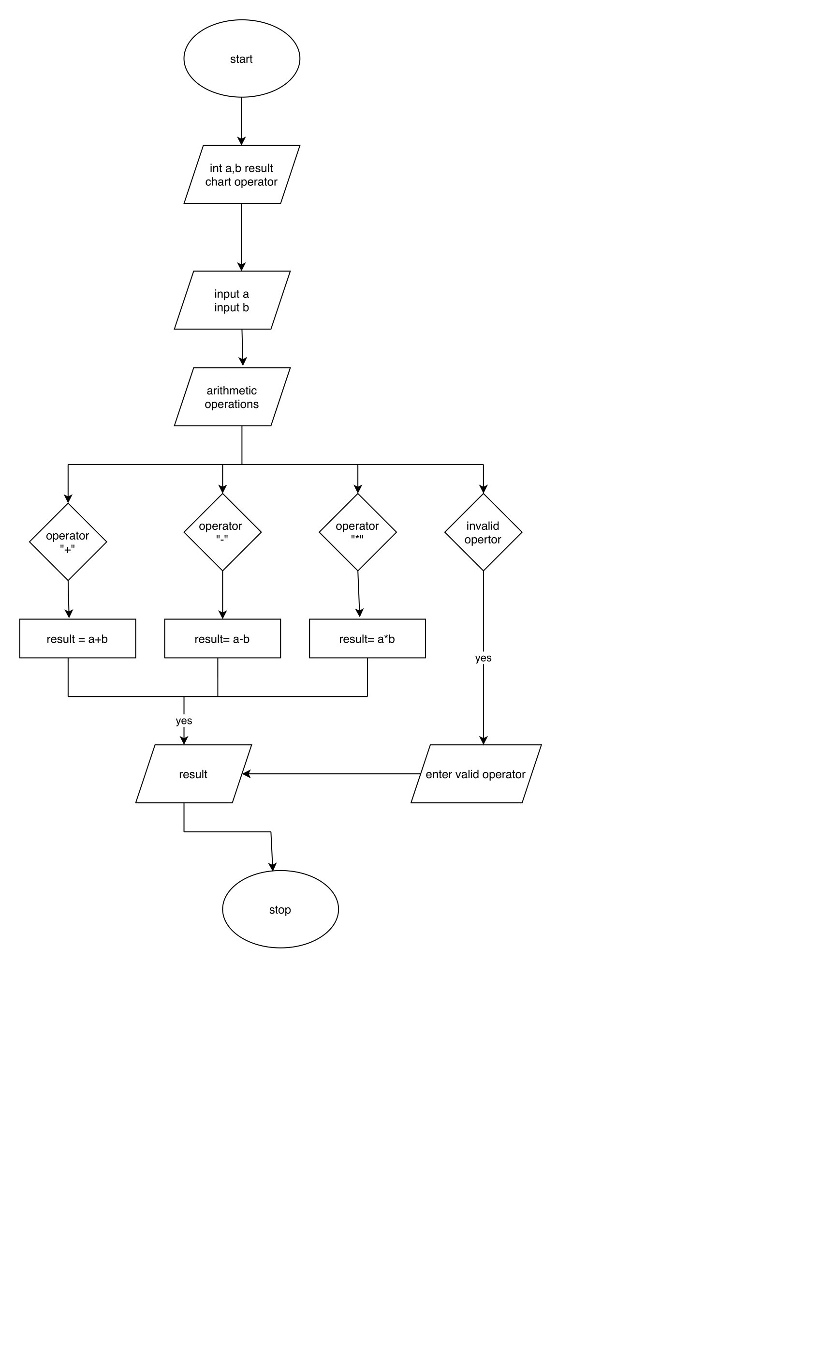

Fig 2: Activity Diagram

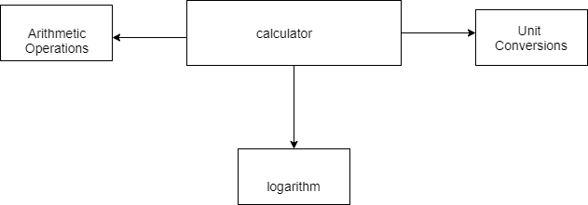

Fig 3: Deployment Diagram

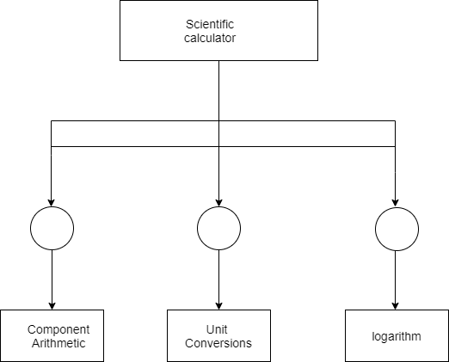

Fig 4: Component Diagram

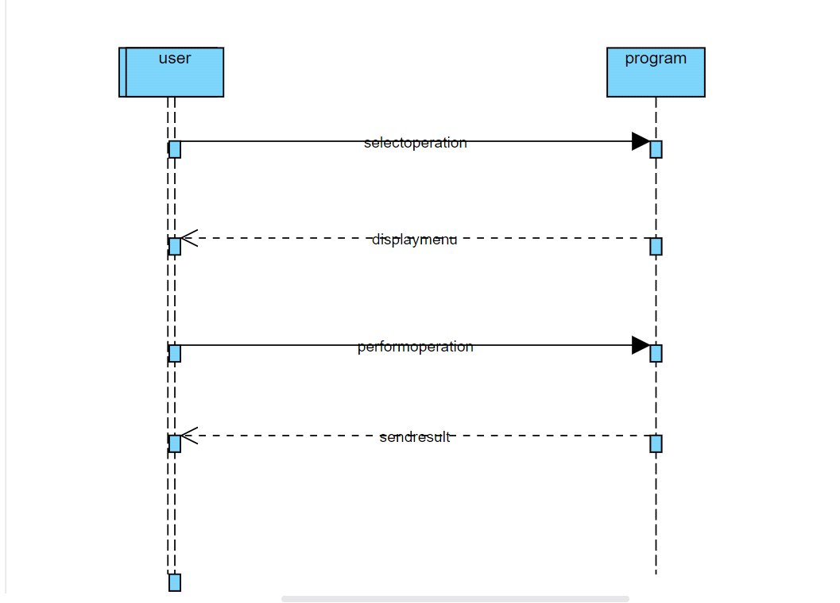

Fig 5: Sequence Diagram